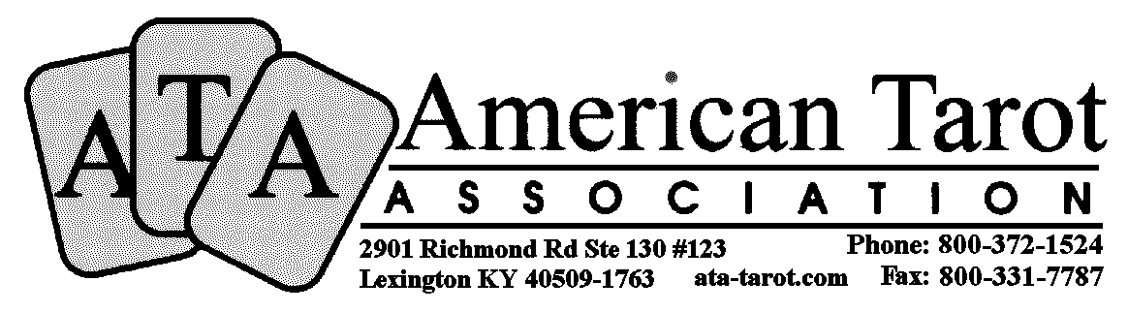

Name ________________________________________________________________
Address ________________________________________________________________
City _______________________________State _________ Zip _______________
Phone Number _______________________ Email______________________________
The information on this form is strictly confidential.

Circle Payment type: Check / Money Order

Make checks Payable to American Tarot Association

Check Number _______________________________________________________________________________

Please circle all that apply New Member / Renewal / Materials and circle your choices below.

Membership Options

Delivery by Internet $25 – One Year $45 – Two Years $65 – Three Years
Networks Administration Fee (No Benefits or Quarterly) $10 per year ____ Number of years.

Materials are not available with Networks membership or to Non-members.

Educational Materials

Internet Delivery is only available for books, which are supplied in PDF format (make sure to include your email address above.)
When ordering Audio please be sure to Circle which format (Tape or CD.)

The audio available for the 100, 200 and 300 courses are based upon our original correspondence course and do not cover some of the material available in the new course books.

Introduction to Tarot (100 Course)

2008 Edition Book $15 Original Edition 4 Tapes/CDs $30 2008 Edition Download PDF $10

Intermediate Tarot (200 Course)

2008 Edition Book $15 Original Edition 4 Tapes/CDs $30 2008 Edition Download PDF $10

Advanced Tarot (300 Course)

2008 Edition Book $15 Original Edition 4 Tapes/CDs $30 2008 Edition Download PDF $10

Mystical System (401 Course)

Book $15 1 Tape/CD $15 Download PDF $10

Astrological System (402 Course)

Book $15 1 Tape/CD $15 Download PDF $10

Numerological System (403 Course)

Book $15 1 Tape/CD $15 Download PDF $10

______________________________________________________ __________________
Signature (denotes that you are at least 18 years old) Date
Form RH-6AP (2012)

